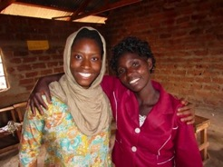
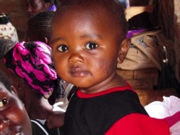
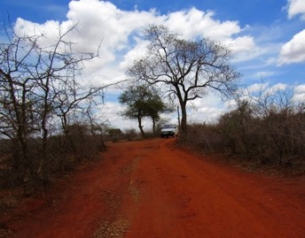
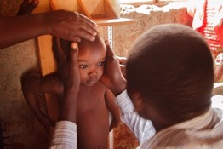
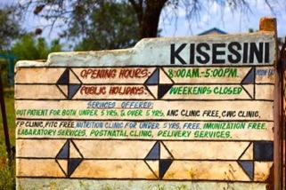
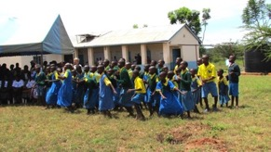
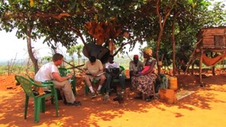
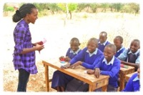
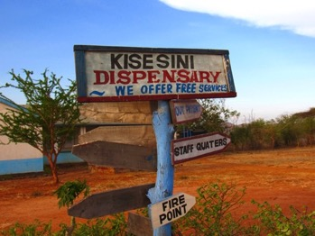
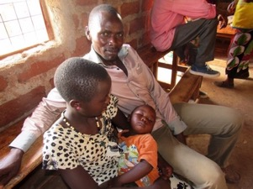
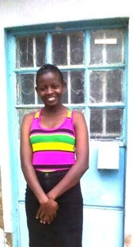
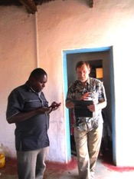
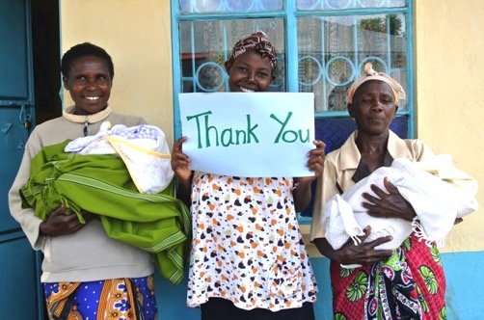
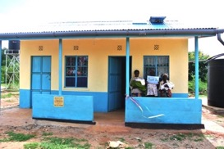
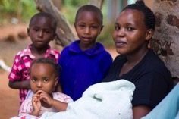
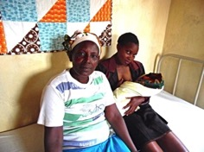
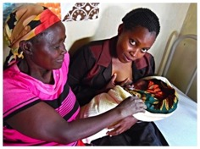
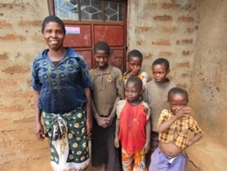
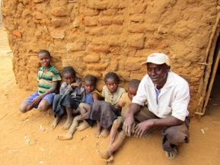
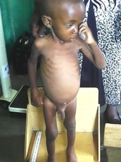
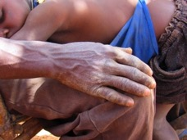
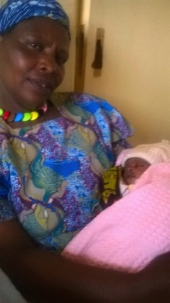
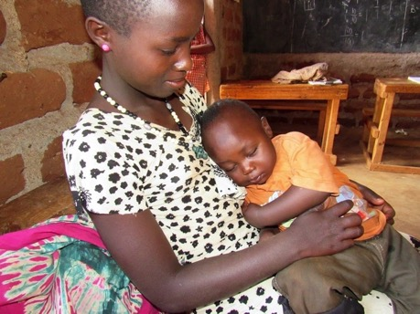
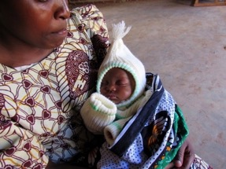
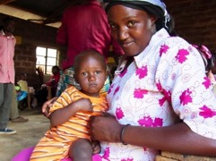
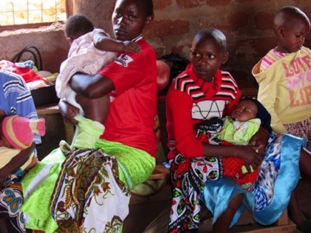
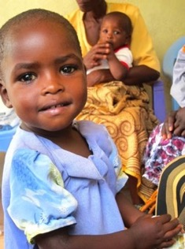
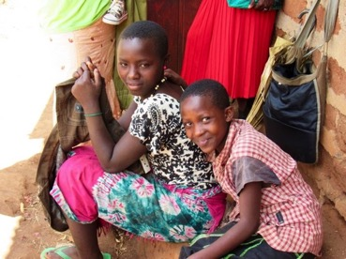
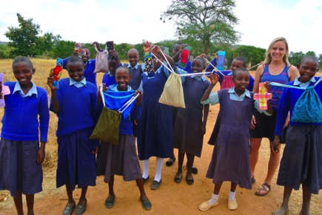
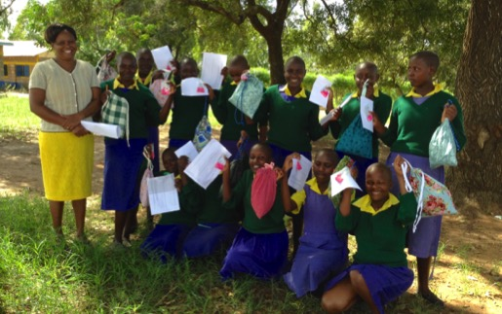
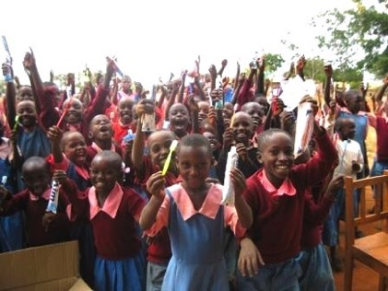
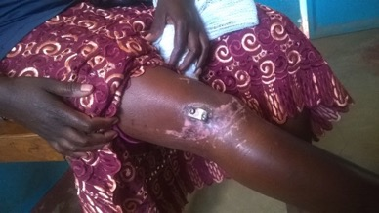
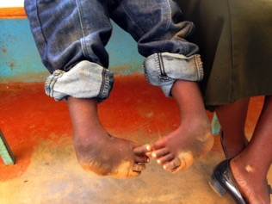

Governance
Board of Directors
Angelo Tomedi, MD, President, Albuquerque New Mexico
Ruth Anne O’Keefe, M.D., Vice President, Albuquerque, NM
David W. Broudy, MPH, Ph.D. Albuquerque, New Mexico
Brian Johnson, M.D. Berkeley, California
Antia Sanchez, RN, Albuquerque, New Mexico
Maria Cassimus, CPA, Albuquerque, New Mexico
Mbarak Hussein, Albuquerque, New Mexico

Global Health Partnerships (GHP) is a non-profit organization of medical professionals and other volunteers who work in developing countries as partners with local community organizations and health care providers to improve the health and well being of the poor and marginalized throughout the world.

Mission Statement

Global Health

Partnerships

the
2015 Annual Report
History of GHP in Kenya

Year in Review

The clinic in Kisesini was started by a Kenyan women’s basket weaving co-op. The women saved some of their basket income to construct a rudimentary building in the village of Kisesini on donated land. GHP raised the funds to complete the facility and purchase the equipment and supplies. As planned, the clinic was designated a Government of Kenya (GOK) facility. GOK can only provide for the salaries of the RN staff and some basic medicine and supplies. GHP arranged the training of a network of lay Community Health Workers (CHWs) who work in their villages to improve child health. This allows GHP to reach all who need care. GHP purchases additional essential medicine and supplies, continues to train CHWs, and sends medical teams twice a year to do volunteer work and teaching. Because of the talent and kindness of the nursing staff, and the fact that GHP supports maternity care, keeps the pharmacy stocked, and provides emergency medical transportation, this clinic is the best in eastern Kenya. GHP is the perfect partnership including the Kenyan Health Ministry, the wonderful Kenyan nurses who deliver care full time, the University of New Mexico School of Medicine and the medical students who research clinic activities.

Global Health Partnerships (GHP) has been providing health care and humanitarian aid in Kenya since September 2007. The Kenya project, called the Kisesini Community Health Project, consists of the Kisesini clinic (Dispensary), a maternity center, and the community projects that focus primarily on village-based maternal and child health. The project serves a population of approximately 50,000 and our service population seems to grow every year. This report covers the GHP fiscal year of July 1, 2014 – June 30, 2015.

ANNUAL REPORT 2015
GLOBAL HEALTH PARTNERSHIPS

Three nurses, a clinical officer, and a laboratory technician provide the primary care services, including normal vaginal deliveries, at the Kisesini Clinic. Nicholas Mutuku is the nurse-in-charge and the volunteer coordinator of GHP projects. The other two nurses are Theresia Waeni Makau and Dorcas Mumbua Kioko. During the 2014-2015 fiscal year there were a total of 20,604 patient visits, which is an increase from the 13,247 in the previous fiscal year. There were 93 vaginal deliveries of healthy newborn infants, and an additional 20 women received care during labor but required transport for complications. During the fiscal year there were 1,558 patients served in outreach clinics. There were 521 dental patients, a 33% increase from last year. Demand for all services is increasing.
GHP purchases the lab supplies and pays the salary of a lab technician, a little more than $200 monthly. GHP has funded emergency transport of patients using the GHP ambulance to a district hospital for a higher-level care. The GHP vehicle is also used for emergency patient transport from remote villages to Kisesini, for pickup and delivery of medication/supplies, and village outreach clinics. The cost of maintaining the vehicle (a Toyota Land Cruiser, modified to serve as an ambulance) is the largest maintenance expense category for the GHP fiscal year at $9,356. Total Kisesini Dispensary expenses for the fiscal year were $21,883. Medications and supplies were the largest expense at $12,164. Nurse stipends for night and weekend coverage totaled $2,942. This provides 24/7 obstetrical coverage. We also pay the salary of one of the nurses at an annual cost of $4,077. Maternity meals and room rental for family cost $215. Total core services for the year cost $32,116.

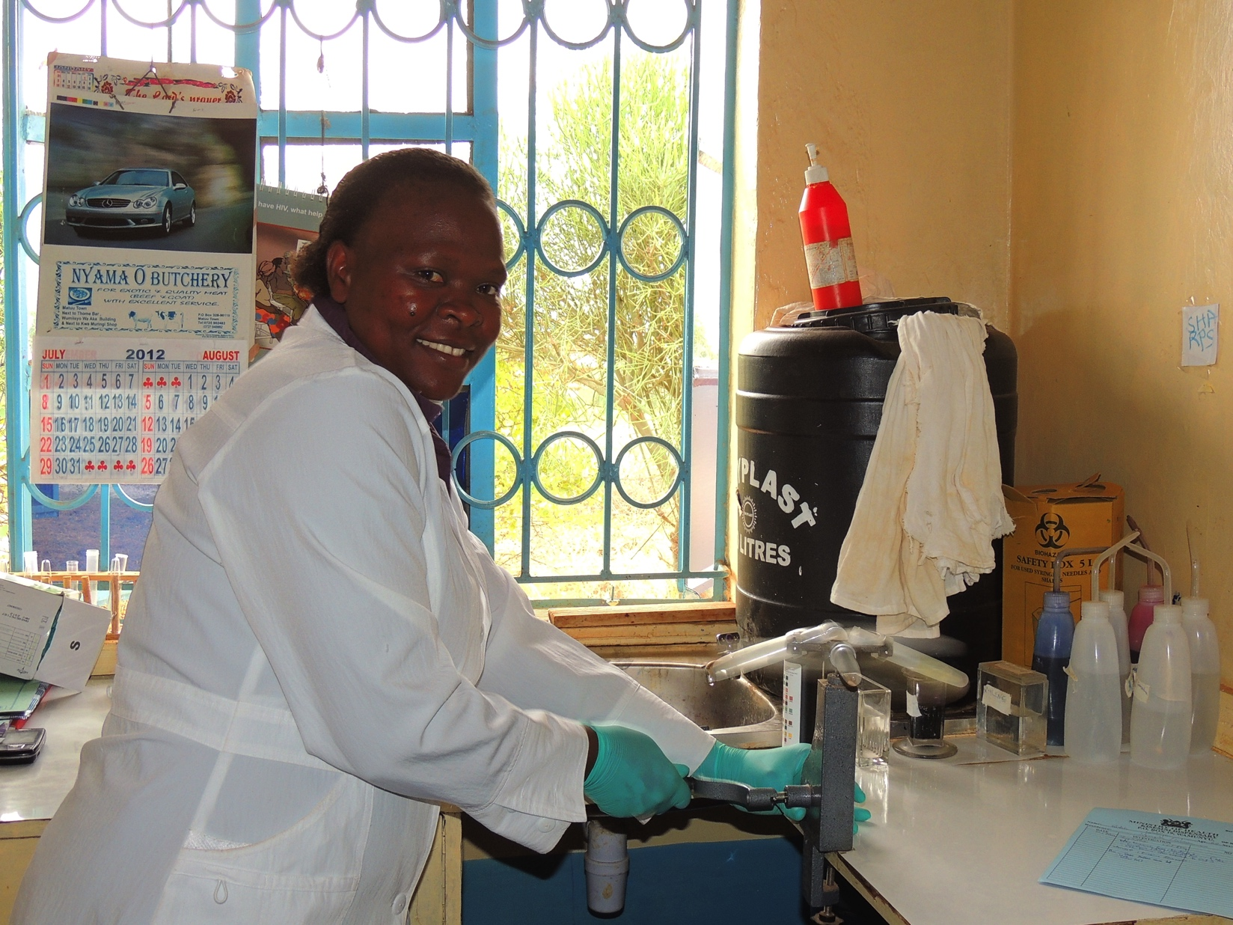

ANNUAL REPORT 2015
GLOBAL HEALTH PARTNERSHIPS

Clinical Services at the Kisesini Clinic
Maternity Center Welcomes 93 Newborns
The new maternity center became operational in March 2014 with a grand dedication celebration. In March of 2012 a Traditional Birth Attendant (TBA) referral project was started. TBAs are asked to bring their patients to the Kisesini Birthing Center for professional medical assistance during childbirth. To help cover their expenses, the TBAs are given a per diem of less than $3.00 per patient brought to the clinic. This program has greatly increased the number of patients who benefit from medically assisted births. This TBA referral program has been so successful the Kenyan Ministry of Health has requested we spread this idea to adjacent medical facilities. This will allow us to triple the number of mothers and infants who can deliver in a safer medical environment. Every mother deserves a medically assisted birth. Our year’s expenses for the TBA referral program were $107. Due to anticipated expansion of this program our projected annual expenses are $700.

ANNUAL REPORT 2015
GLOBAL HEALTH PARTNERSHIPS
Malnutrition (undernutrition) is an important underlying cause for many childhood deaths, and results in growth, neurological and development problems of the surviving children. From 2009 to 2014 GHP has treated 238 children with severe or moderate malnutrition. This community-based program provides treatment in the child’s home, rather than in a hospital or a centralized therapeutic feeding center. The treatment uses Plumpy’nut® (a fortified peanut-based product) for the most severely affected children, and Unimix® (a fortified corn-soy flour blend) or PlumpySup for those less severely affected. GHP, in conjunction with the University of New Mexico School of Medicine, is doing a follow-up study on these formerly malnourished children. The development as well as the growth of these children is being assessed in that study. Preliminary findings confirm what we had thought. Although the final results are pending, early data shows the recurrence rate of malnutrition after completion of treatment is low and the mental and physical development of the children is remarkably good. Never give up on these children.
GHP has been providing food and education for the very poorest families that are most in need. Currently 22 families receive a monthly food ration. The annual expense for this program has been $15,012 with $8,168 in food costs and $6,843 in school expenses. These families are extremely poor and wracked with health problems. The families are usually identified by CHWs with verification on home visits by Nicholas the head nurse or a GHP member. They are very grateful for the chance to raise and educate their children. These families could not survive without GHP’s help.
GHP also has implemented a project for prevention of child malnutrition. Four CHWs have been trained to provide counseling of mothers and pregnant women about child feeding and hygiene starting during pregnancy and continuing until the children reach 24 months of age. The total annual cost of this program is about $200. The University of New Mexico is conducting a study of the effectiveness of this project to prevent child malnutrition.

Community-Based Services

Treatment of Childhood Malnutrition

GOBAL HEALTH PARTNERSHIPS
ANNUAL REPORT 2015
In Kenya the child mortality rate (the number of children who die before 5 years of age) is 52 deaths per 1,000 births. Neonatal mortality, the most dangerous period of all for children, is 22 deaths per 1,000 births. GHP has implemented a project of home visits, conducted by 30 specially trained CHWs, for newborn infant evaluation, as recommended by UNICEF for low-income countries like Kenya. University of New Mexico funds have paid for the training and some of the operating costs of this program. UNM students have studied the efficacy of this program. The CHWs visit the newborn infants 3 times during the first week of life, taking their temperature, counting their breathing rate, observing their feeding progress, and looking for early signs of infection so that prompt treatment can be arranged. 1,061 newborn infants were visited this year. 37 infants were referred by CHWs for illness. Only 3 infants died during their first week of life. This is a 75% reduction in expected neonatal mortality. This program has made a huge difference in the survival rates of newborn infants in the Kisesini Dispensary service area. The CHWs are paid a per diem of $3.30 per visit, or about $10 for all 3 newborn visits. Our annual expenses for this program were $7,371. This program has been so successful it must be expanded. Our projected annual expenses for next year are $10,504.

Improving Newborn Infant Care
ANNUAL REPORT 2015
GLOBAL HEALTH PARTNERSHIPS

Outreach clinics deliver preventive health care services to the more remote villages of the catchment area where access to care is limited for many families. GHP supports weekend outreach clinics that focus on maternal and child health including immunizations for children, family planning services, prenatal care, and treatment of child malnutrition. The GHP outreach clinics are conducted on two weekends each month and are staffed by the Kenya nurses and coordinated by the Community Health Workers. The services provided include immunizations, vitamin A supplements for children, deworming, and growth and nutrition assessment. Women are provided with family planning services (Depoprovera injections and birth control pills). Pregnant women are seen for prenatal care. During this past year a total of 1,558 patients were seen in very remote villages of the sublocations of Syokisinga and Mekilingi. 1,041 children were seen for immunizations and nutritional assessment. 383 women were seen for family planning, and 135 women were seen for prenatal care. The total expense of this program was $2,030. In spite of the grueling day required of our nursing staff to conduct these clinics, this is truly one of our best programs for the investment. These outreach clinics deliver healthcare to people who would otherwise never have such care.

ANNUAL REPORT 2015
GLOBAL HEALTH PARTNERSHIPS
Village Outreach
Access to education is important for the health of adolescents and has a substantial impact on future economic activity of women. From a public health standpoint, child health as well as maternal health are strongly associated with mothers’ educational attainment. There is an enormous effect of increased education of women on child mortality. One recognized barrier to school attendance for girls that has been receiving increased attention is the onset of menstruation and the difficulties that girls encounter with a lack of availability and affordability of sanitary hygiene products. There is also a severe lack of puberty education.
GHP has launched a project to provide sanitary products (sanitary pads) and medication to treat menstrual symptoms (cramps and bleeding). Girls who have started their menstrual period and are attending 7th and 8th grades of primary schools in the GHP catchment area are given a supply of washable reusable sanitary pads, one pair of underwear, and a monthly supply of ibuprofen, and puberty education. A charitable organization, Days for Girls, http://www.daysforgirls.org/, has donated the menstrual kits.
The impact of this project will be evaluated in a study by the University of New Mexico. The primary outcome for this study is school performance measured by the grades of the students. The difference (before and after the intervention) in grade scores of the girls will be studied, and compared to a control group of school girls who have not received the sanitary pads or medication. The study will be completed in December this year. At that point we hope to have enough sanitary hygiene products and medication to include the girls in the primary schools in the catchment area that have not yet been included.

Menstrual Hygiene Project
ANNUAL REPORT 2015
GLOBAL HEALTH PARTNERSHIPS
Referrals for Specialist Care

Because the Kisesini Dispensary has such a good reputation for helping those in need, we are getting more and more requests for assistance in referring and financing specialist care. Most of the cases have been orthopaedic and cardiac. Our expenses for these patients who require surgery in Nairobi this past year have been $6,566. We wish we could do more.
In rural Kenya access to dental care is very limited and expensive, out of reach for the poor. The pain and suffering from untreated toothaches and dental abscesses are common. GHP has supported a weekend dental clinic in Kisesini in order to meet this need. All patients are given instructions in preventive oral health and provided with free medications, toothbrushes and toothpaste. This past year a total of 521 patients were seen for dental care at a cost of $12,505.

ANNUAL REPORT 2015
GLOBAL HEALTH PARTNERSHIPS

Dental Care in Kisesini
GLOBAL HEALTH PARTNERSHIPS
ANNUAL REPORT 2015
Revenue:
Contributions $78,642.54
Safari Run 5,433.12
UNM Grants 3,091.14
Investment Income 106.36
___________
$87,273.16

Expenses:
Outreach Clinics $ 2,030.29
CHS Newborn 103.29
Clinical
Nurse Dorcas 1,936.84
Lab 2,484.56
Meds 11,378.30
Nurses 2,139.77
Weekend coverage 2,941.79
Supplies 785.87
Dental Program 12,504.77
Food and school for poor 15,011.58
Auto and transport 10,232.88
Maternal/infant 215.38
Maternity center/building 762.10
Maternity all costs 3,403.58
Newborn visitation 7,370.52
Nutrition project 2,086.54
Specialty referrals 6,565.55
TBAs 106.84
Other UNM costs 4,917.14
___________
Total Operating Expenses $86,977.96

Administrative expenses
Postage, bank fees, etc. 1,832.50
Net Loss -1,537.30
2015 Financial Review
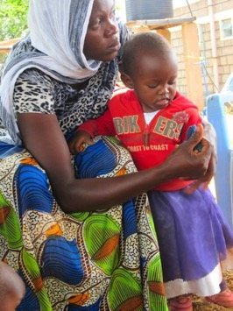
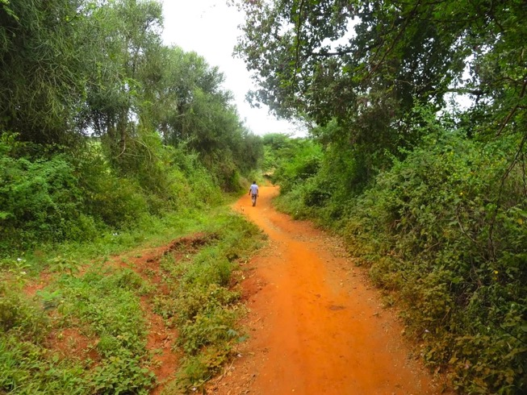
Global Health Partnerships
PO Box 4385
Albuquerque, New Mexico 87196
ghp-usa.org

GHP is a 501(c)(3) non-profit organization

Our dream is to expand the services we support at our clinic in Kisesini. We want every mother, child, and family within our service area to enjoy the best possible health. 100% of your donations go toward this dream.

Global Health Partnerships
Annual Report 2015

